Activity 7: Correlation Detective
Ayesha Siddiqa S
192324305
1. The matrix
Aim: To calculate the correlation matrix for all seven variables and visualize it using a correlogram.
Calculation:
- Number of observations: \(n=14\)
- Number of variables: \(p=7\)
- Number of distinct variable pairs:
\[ \frac{p(p-1)}{2}=\frac{7(7-1)}{2} =\boxed{21} \]
R program:
set.seed(100353)
n <- 14
pressure <- round(rnorm(n, 51.9, 13.9), 1)
coffee <- round(156 + 52.0 * (0.95 * (pressure - 51.9) / 13.9 +
0.30 * rnorm(n)), 0)
late_entries <- round(61 + 20.8 * (-0.87 * (pressure - 51.9) / 13.9 +
0.50 * rnorm(n)), 0)
room_dev <- round(seq(-4.7, 4.7, length.out = n)[order(runif(n))], 1)
study_complaints <- round(2.6 + 10.3 * (room_dev / 4.7)^2 +
rnorm(n, 0, 0.7), 0)
group_sessions <- round(rnorm(n, 10, 3.5), 0)
print_jobs <- round(208 + 69.3 * (0.18 * (group_sessions - 10) / 3.5 +
0.98 * rnorm(n)), 0)
group_sessions[13] <- 22
print_jobs[13] <- 423
case <- data.frame(pressure, coffee, late_entries, room_dev,
study_complaints, group_sessions, print_jobs)
# Correlation matrix rounded to two decimal places
cor_matrix <- round(cor(case), 2)
print(cor_matrix)

# Correlogram using ggplot2
library(ggplot2)

cor_long <- as.data.frame(as.table(cor(case)))
names(cor_long) <- c("Variable1", "Variable2", "Correlation")

ggplot(cor_long, aes(Variable1, Variable2, fill = Correlation)) +
geom_tile(color = "white") +
geom_text(aes(label = sprintf("%.2f", Correlation)), size = 3) +
scale_fill_gradient2(low = "blue", mid = "white",
high = "red", midpoint = 0,
limits = c(-1, 1)) +
coord_fixed() +
labs(title = "Correlation Detective: Case CD-D04",
x = NULL, y = NULL, fill = "Correlation") +
theme_minimal() +
theme(axis.text.x = element_text(angle = 45, hjust = 1))

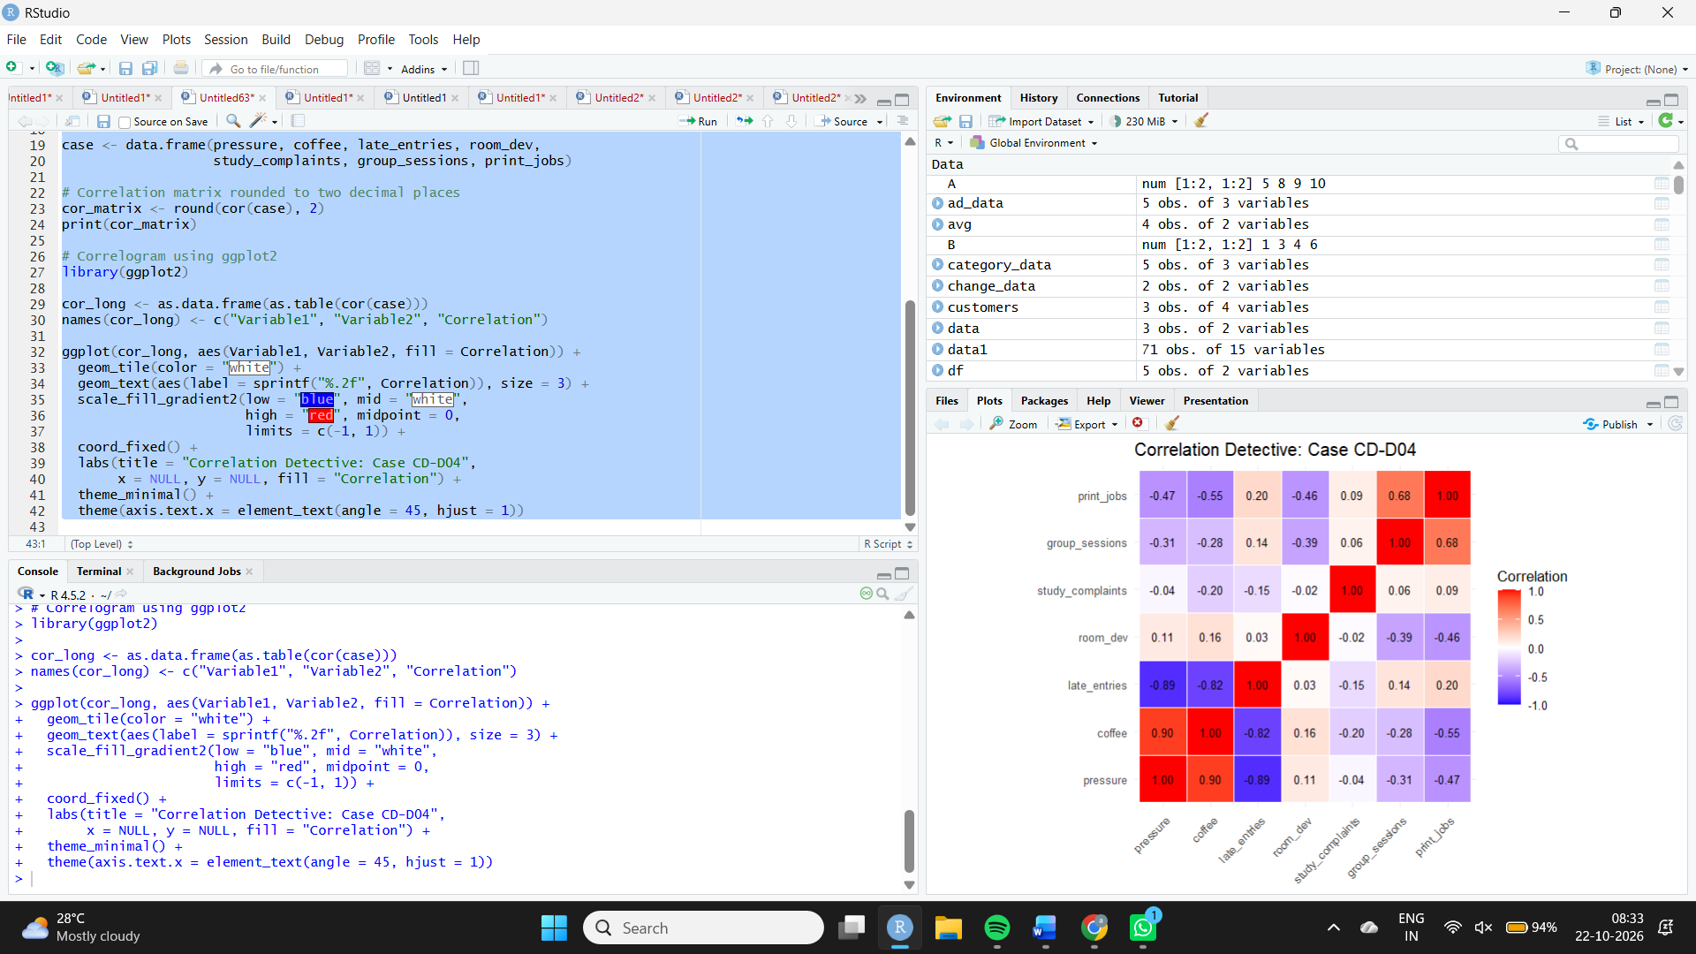
Observation : The correlation matrix contains seven variables and 21 distinct off-diagonal pairs. The correlogram shows positive correlations in red, negative correlations in blue, and correlations near zero in white.
2. The strongest clues
Aim: To identify the strongest positive and negative linear relationships in the correlation matrix.
R program
M <- cor(case)
diag(M) <- NA

positive <- which(M == max(M, na.rm = TRUE), arr.ind = TRUE)[1, ]
negative <- which(M == min(M, na.rm = TRUE), arr.ind = TRUE)[1, ]

cat("Strongest positive pair:\n")
print(c(Variable1 = rownames(M)[positive[1]],
Variable2 = colnames(M)[positive[2]],
r = round(M[positive[1], positive[2]], 2)))

cat("Strongest negative pair:\n")
print(c(Variable1 = rownames(M)[negative[1]],
Variable2 = colnames(M)[negative[2]],
r = round(M[negative[1], negative[2]], 2)))

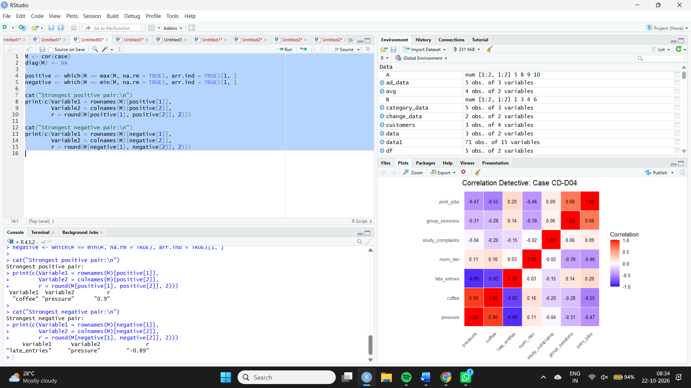
Interpretation: Coffee sales are designed to increase with exam pressure, while late-night entries are designed to decrease with exam pressure. The strongest pairs and their exact correlation coefficients should be taken from the program output.
3. The deceptive zero
Aim: To compare a straight-line relationship with a quadratic relationship between room temperature deviation and study-room complaints.
R program
# Scatter plot with straight-line and quadratic fits
ggplot(case, aes(x = room_dev, y = study_complaints)) +
geom_point(size = 3) +
geom_smooth(method = "lm", formula = y ~ x,
se = FALSE, color = "blue") +
geom_smooth(method = "lm", formula = y ~ x + I(x^2),
se = FALSE, color = "red") +
labs(title = "Room Temperature and Study-Room Complaints",
x = "Room Temperature Deviation (degrees C)",
y = "Study-Room Complaints") +
theme_minimal()

# Pearson correlation
r_room <- cor(case$room_dev, case$study_complaints)
cat("Pearson correlation =", round(r_room, 4), "\n")

# Quadratic model and R-squared
quad_model <- lm(study_complaints ~ room_dev + I(room_dev^2),
data = case)
cat("Quadratic R-squared =", round(summary(quad_model)$r.squared, 4),
"\n")
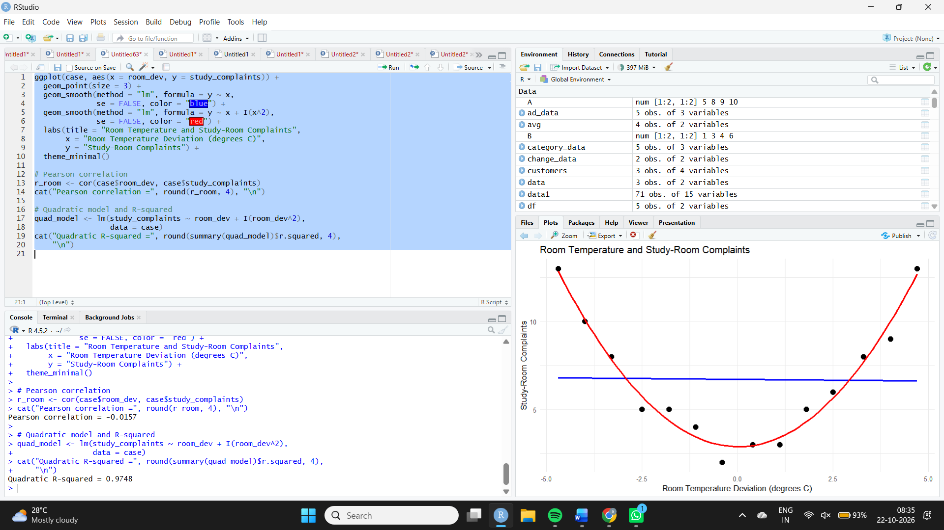

Answer for the explanation:
Pearson's correlation measures a straight-line relationship, so it can be close to zero when a strong U-shaped, nonlinear relationship exists. The quadratic model captures the curvature and should provide a better fit than the straight-line model.
Record the exact Pearson \(r\) and quadratic \(R^2\) printed by R in your answer.
4. The outlier alibi
Aim: To examine the relationship between group sessions and print jobs and determine how an unusual record affects correlation.
R program
# Scatter plot, highlighting the suspected outlier
ggplot(case, aes(x = group_sessions, y = print_jobs)) +
geom_point(size = 3) +
geom_text(aes(label = seq_len(nrow(case))),
nudge_y = 8, size = 3) +
geom_smooth(method = "lm", formula = y ~ x,
se = FALSE, color = "blue") +
labs(title = "Group Sessions vs Print Jobs",
x = "Group Sessions Booked",
y = "Print Jobs",
caption = "Point labels indicate row numbers") +
theme_minimal()

# Correlation with every record
r_all <- cor(case$group_sessions, case$print_jobs)

# Correlation after excluding row 13
case_without_13 <- case[-13, ]
r_without_13 <- cor(case_without_13$group_sessions,
case_without_13$print_jobs)

cat("Correlation with all rows =", round(r_all, 4), "\n")
cat("Correlation without row 13 =", round(r_without_13, 4), "\n")
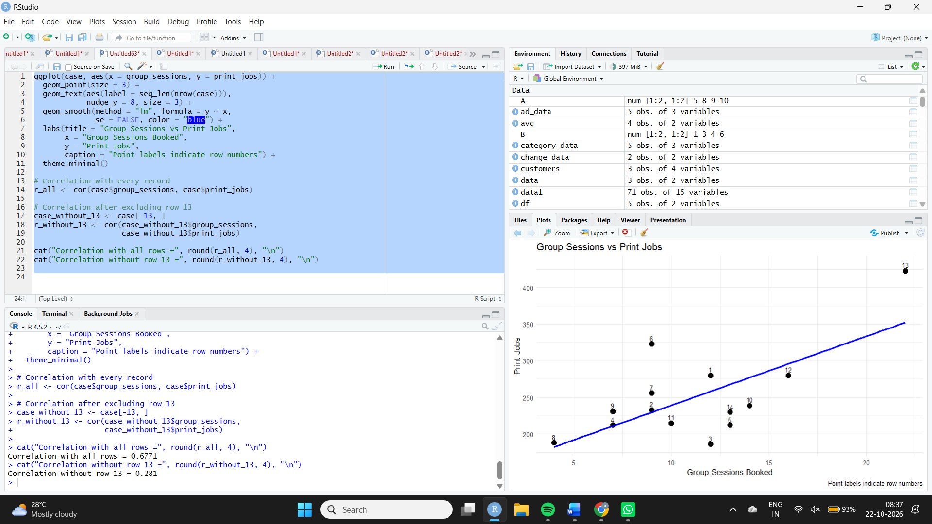
Answer:
- Suspected incorrect record: Row 13.
- Its group-session value was changed to 22 and its print-job value to 423.
- The two printed correlation values show how much the unusual record changes the linear relationship.
Conclusion: A single extreme observation can substantially inflate or otherwise distort Pearson's correlation. Compare the two reported values to state whether the correlation increases or decreases when row 13 is included.
5. The prime suspect
Aim: To determine whether the relationship between coffee sales and late-night entries remains after controlling for exam pressure.
R program
# Raw correlations
r_coffee_late <- cor(case$coffee, case$late_entries)
r_pressure_coffee <- cor(case$pressure, case$coffee)
r_pressure_late <- cor(case$pressure, case$late_entries)

cat("Correlation: coffee and late entries =",
round(r_coffee_late, 4), "\n")
cat("Correlation: pressure and coffee =",
round(r_pressure_coffee, 4), "\n")
cat("Correlation: pressure and late entries =",
round(r_pressure_late, 4), "\n")

# Partial correlation controlling for pressure
coffee_resid <- resid(lm(coffee ~ pressure, data = case))
late_resid <- resid(lm(late_entries ~ pressure, data = case))

partial_r <- cor(coffee_resid, late_resid)
cat("Partial correlation controlling for pressure =",
round(partial_r, 4), "\n")
